“The hardest class in all of computer science” - Wei Wei

“I’m the teacher you want, to pass the class”

Practice every day for one hour, don’t front or back load the class.

Extra credit is important and should be attempted every class (around 20) for an extra 3% on the final grade **\* 2**

* Code for Thought (3%)
* iClicker (3%)

93/100 = 87 extra credit!!!

Should already be pretty good when going to labs

Work hard, plan ahead, time management

Exams become very difficult (1 fine, 2 slight problem, 3 extremely tough)

All assignments are submitted to gradescope

Plan code thoughtfully rather than patching a sinking boat

Start of real class:

* C programming:
  + In this course C99
  + Design principle
    - Support low-level memory access
    - Powerful
    - Simple
    - **Fast**
    - Popular
  + C is a purely procedural language
    - No object-orientation whatsoever
  + Central Dogma
    - Object of interest compilations
    - Main abstraction tool procedures/functions
  + Procedural Programming in C
    - Adheres to the philosophy
    - Generates very efficient code
    - PRovides full control over memory management
* Needed:
  + C compiler: gcc or cc
  + A linker:
  + A text editor: any
* The GNU toolchain

Workflow

* Text editor to compiler to …

Comments:

//single line

/*

Muti line

*/

The main function:

#include <stdio.h>

int main(void)

{

printf(“Hello world!/n”); //print function /n is newline

return 0; //means “everything went according to plans” number can be read

}

#include

Imports a header file with the specification of functions

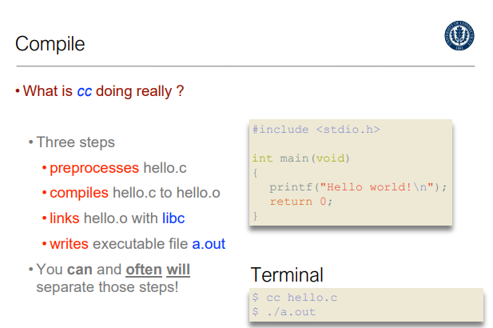

Standard Input:

Int i, n, sum; //local variable

scanf(“%d”, &n); //takes input as n (d means integer)

printf(“Sum from 1 to %d = %d/n”, n sum); //”Sum from 1 to n = sum”

return 0;

Variables must be declared before used

Statements end with ;

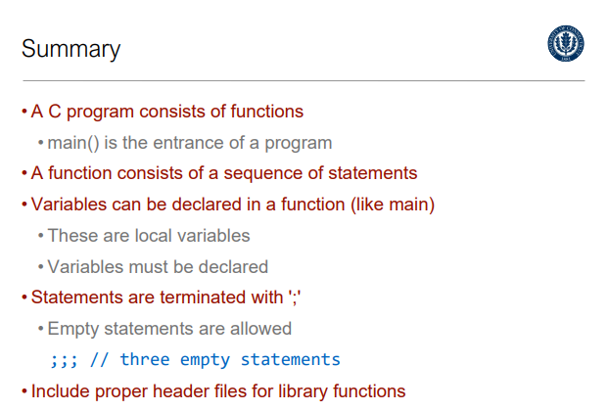

The main function can take two arguments:

Argc the number of arguments

Argv an array of arguments

Will learn how to use later

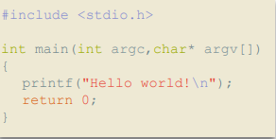

If-else statement

“In coming weeks”

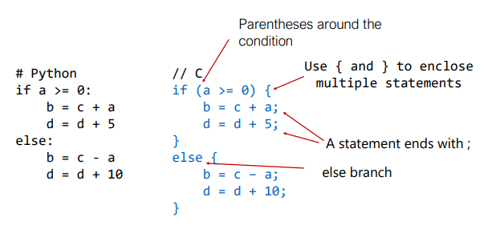

Summary of Week 1:

| 3100 is going to be my hardest class, however I will be given time before it gets really difficult. Most people are learning C from scratch. I should use this time to study the book. Try not to take any Credit for this class for granted. |
| --- |